

AI-Driven Hyper-Personalization & Recommendations

Leveraging AI for Personalized Financial Insights



March 26, 2025

team nAME: lAZY4

Team Members: Suchismita Das, Shilpa Rao S, Naveen Bojanala, Yellareddy Hoskote

**Overview**

**The Hyper-Personalized Financial Recommendation System is an AI-driven solution designed to provide tailored financial product recommendations to users based on their transaction history, financial goals, risk profiles, and real-time market trends. This system integrates advanced machine learning techniques, natural language processing (NLP), and sentiment analysis to ensure accurate and user-specific recommendations.**

**Functionality:** The hyper-personalized recommendation system aims to deliver highly tailored financial product recommendations to individual users by leveraging their transaction history, financial profiles, market trends, and sentiment analysis.

* **Key Goals**:
  + Understand and analyse user behaviour, financial goals, and risk tolerance.
  + Provide recommendations that match the user's context and preferences, including budget, market trends, and sentiment-driven insights.
  + Educate users with resources relevant to their financial goals.
  + Log recommendations and user interactions for review and improvement.

**Key Features**

1. **Dynamic Recommendation Engine**:
   * Combines transaction history embeddings with contextual data (goal, risk profile, market trends).
2. **User Profiling:**
   * Captures user details such as income, risk profile, goals, and transaction history.
3. **Embedding Generation:**
   * Embeds user transaction data using NLP models like DistilBERT (generate_embeddings).
   * **Embedding pipeline** within the Hugging Face Transformers library, simplifies the process of generating embeddings for text, images, or for personalized financial insights.
4. **Sentiment-Driven Insights**:
   * Analysing sentiment from financial news using **s** and TextBlob to assess product sentiment (analyze_sentiment_vader).
   * Enhances the recommendation engine with sentiment-driven scores.
5. **Market Trend Integration**:
   * Fetches Real-time market data using the **Alpha Vantage API**.
   * Incorporates market trends like Bullish, Bearish, or Neutral into recommendations.
   * **Bullish:** A market or investor is considered "bullish" when they expect prices to rise. This reflects optimism about growth, profits, or the overall economic outlook.A "bull market" refers to an extended period of rising prices, often in stocks, commodities, or cryptocurrencies.
   * **Bearish**: A "bearish" outlook indicates a belief that prices will decline. It reflects pessimism or caution about future market performance.Negative investor sentiment due to factors like economic slowdown, geopolitical tensions, or poor earnings reports.A "bear market" refers to a prolonged period of falling prices (typically a decline of 20% or more from recent highs).
   * **Neutral:** A neutral sentiment occurs when there is no clear expectation of significant price movement in either direction. It suggests balanced or mixed opinions among market participants. Investors may adopt a "wait-and-see" approach, looking for more clarity before making decisions. Often observed in times of uncertainty or during transitions between bullish and bearish phases.
6. **Educational Recommendations**:
   * Suggests financial education materials tailored to user goals (get_educational_material).
   * Provides users with financial advice based on their goals, such as retirement planning and investment strategies.
7. **Contextual Scoring**:
   * Matches user data with products dynamically by goal, risk profile, budget, and sentiment scoring.
   * Combines user preferences, sentiment insights, and market trends to rank and recommend top financial products.
8. **API Endpoint**:
   * Accessible through a /recommend API endpoint, allowing integration with web-based applications (app.route).
   * Example: [127.0.0.1:5000/recommend?userID=U002&goal=Buying a House&risk_profile=Moderate&city=New York&budget=500000](http://127.0.0.1:5000/recommend?userID=U002&goal=Buying%20a%20House&risk_profile=Moderate&city=New%20York&budget=500000)

**Methodology**

* + 1. **Data Preparation**
* User transaction histories, income, risk profiles, and goals are loaded from an Excel file.
* Embeddings are generated using NLP models for the transaction_history column.



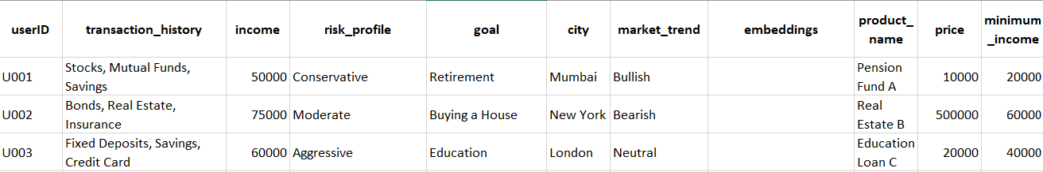

* + 1. **Embedding Generation**
* **DistilBERT** transforms transaction histories into feature vectors for similarity computations (generate_embeddings).

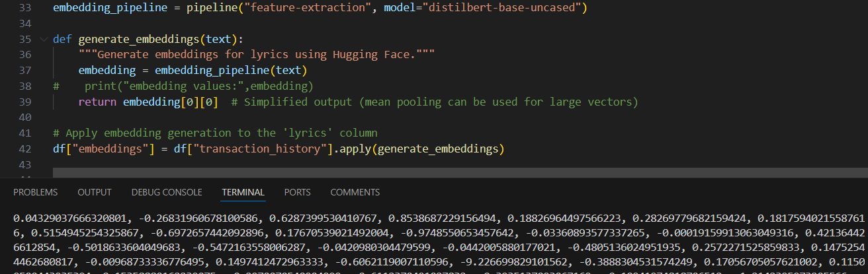

* + 1. **Contextual Scoring**
* Cosine similarity is calculated between user embeddings and all available embeddings for products (cosine_similarity).
* Scores are adjusted for contextual factors like goal match, market trend alignment, and sentiment scores.

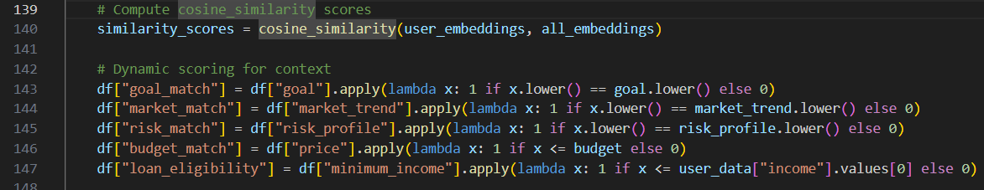

* + 1. **Sentiment Analysis**
* **VADER** analyses headlines related to financial products, providing compound sentiment scores to refine recommendations.

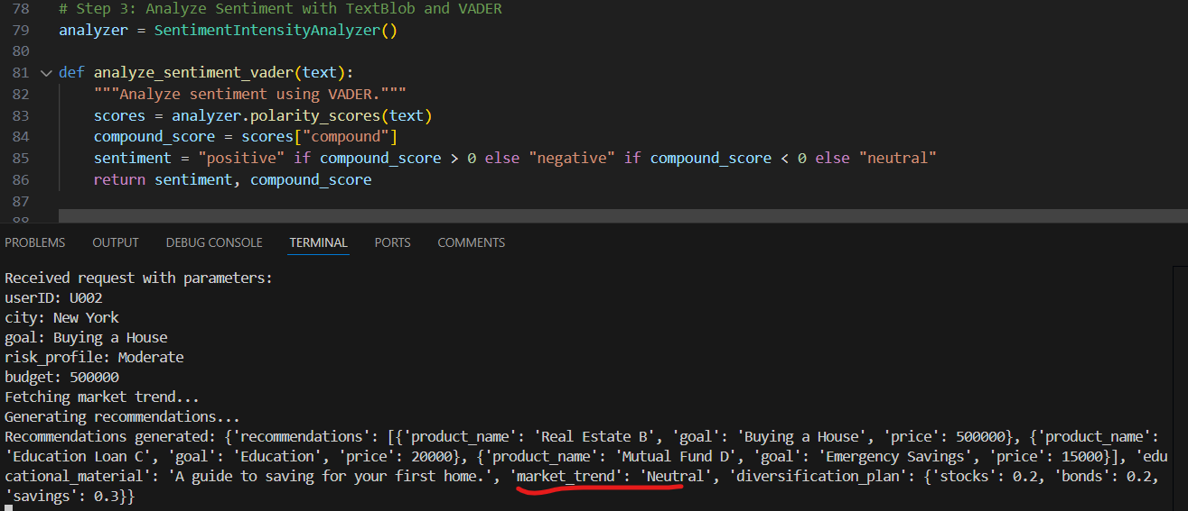

* + 1. **Recommendation Logic**
* Combines similarity scores and contextual factors to calculate a weighted score for each product.
* Top N recommendations are ranked and returned to the user.

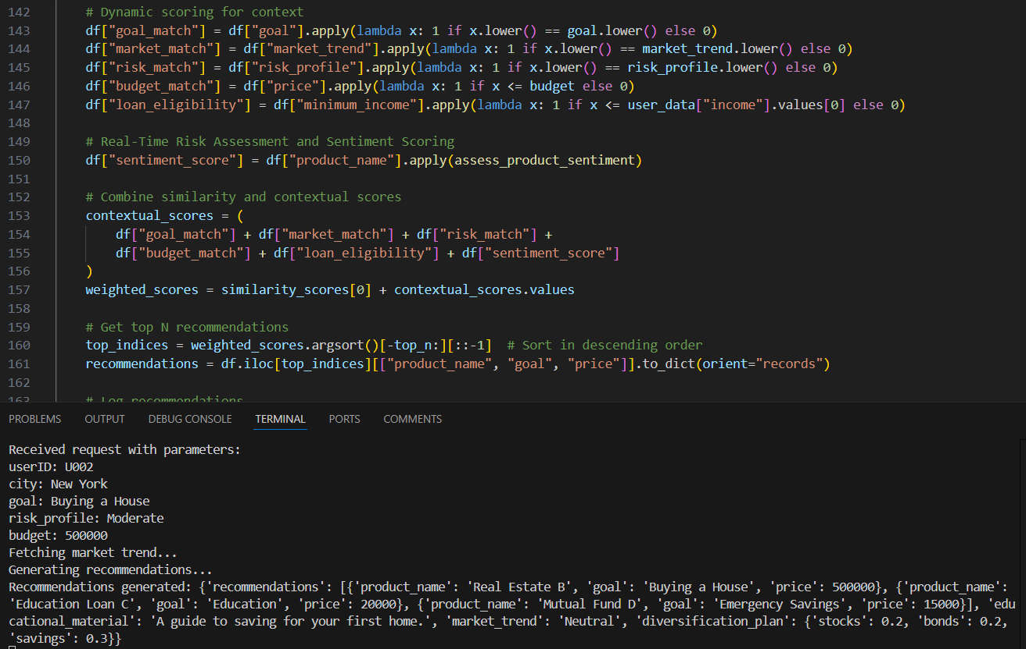

**Model Selection**

1. **Transformer Model** (DistilBERT):
   * Efficient NLP model used for generating embeddings.
   * Provides feature vectors that capture semantic meaning of user transaction histories.
2. **VADER for Sentiment Analysis**:
   * Fast, rule-based sentiment analyser for financial news.
   * Ideal for short text like headlines.
3. **Cosine Similarity**:
   * Lightweight and effective similarity measure for comparing embeddings.

**Unique Points**

1. **Holistic Integration**:
   * Combines market trends, sentiment analysis, and transaction history embeddings for comprehensive recommendations.
2. **Educational Component**:
   * Provides tailored educational materials to empower users in financial decision-making.
3. **Ethical Design**:
   * Transparency in logging recommendations ensures accountability and traceability.
4. **Real-Time Insights**:
   * Dynamic integration with APIs for live market trend data.
5. **Automated File Handling:**
   * The RotatingFileHandler automatically appends to the log file and manages its size, ensuring log rotation when the file exceeds the specified limit.
   * The logger centralizes all logging activity, making it easier to maintain and extend. You avoid repetitive code for manually opening, writing, and closing files.

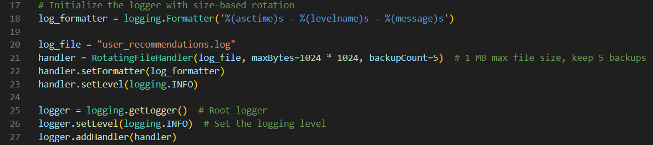

**Ethical Considerations**

1. **Data Privacy** **and Security**
   * Secure handling of user data and compliance with data protection regulations (e.g., GDPR).
   * Logging user interactions must exclude sensitive or identifying information.
2. **Bias and Fairness**:
   * Ensure recommendations are unbiased and equitable, avoiding favouritism based on demographics or socioeconomic status.
3. **Accuracy of Information**:
   * Reliance on APIs like Alpha Vantage and sentiment models necessitates validation to avoid misleading trends or news.
4. **Transparency:**
   * Recommendations are logged for accountability and review.
5. **Explainability**:
   * Users must understand why a recommendation is made, fostering trust and informed decision-making.

**Insights**

1. **User Behaviour Analysis**:
   * Transaction histories reveal patterns such as spending preferences, investment habits, and risk tolerance.
2. **Market Trends Impact**:
   * Incorporating real-time market trends makes recommendations adaptive to economic conditions.
3. **Sentiment-Driven Opportunities**:
   * Positive sentiment around a financial product boosts user confidence in investments.

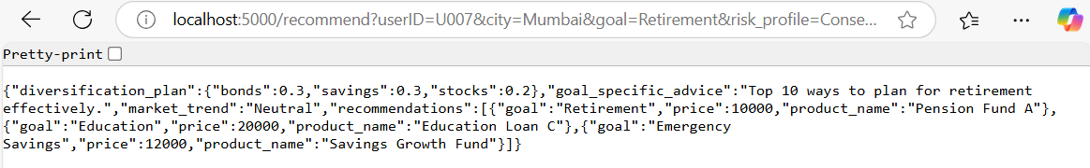

**AI-Driven Findings**

1. **Embedding-Based Personalization**:
   * DistilBERT embeddings effectively encapsulate semantic meaning, enabling personalized recommendations.
2. **Sentiment as a Differentiator**:
   * Adding sentiment analysis of headlines enhances product relevance and user trust.
3. **Real-Time Adaptability**:
   * Integration of APIs ensures recommendations stay relevant in rapidly changing market conditions.
4. **Contextual Scoring Refinement**:
   * Combining similarity with contextual factors provides nuanced recommendations tailored to individual needs.

**Limitations**:

| **Limitation** | **Suggested Solution** |
| --- | --- |
| Expensive Hugging Phase models | Precompute embeddings, use mean pooling |
| Real-time API dependency (Alpha Vantage) | Add caching and retry logic |
| Hardcoded thresholds/ Values | Train models for dynamic thresholding |

**Future Enhancements**

1. **User Feedback Loop**:
   * Incorporate feedback to refine recommendations.
2. **Advanced Sentiment Analysis**:
   * Use GPT models or more advanced language models for sentiment insights.
3. **Interactive Education**:
   * Create interactive financial education resources for deeper user engagement.
4. **Multilingual Support**:
   * Support users in multiple languages for global applicability.
5. **Static educational content**
   * Dynamically generate personalized content

This system represents a forward-thinking, AI-driven approach to financial product recommendations, integrating NLP, sentiment analysis, and real-time data to enhance personalization.